A literature Review: Advancements in AI-Based Models for Road Safety: Predicting Crash Frequency and Severity through Analysis of Data from Several Sources
M.S. Butt, M.A. Shafique 2024

Abstract:
The landscape of road safety has been significantly transformed by the advent and progression of artificial intelligence (AI) and machine learning (ML) technologies. These advancements have led to the development of innovative approaches aimed at predicting crash frequency and severity, marking a paradigm shift from traditional safety measures to data-driven strategies. This comprehensive literature review delves into the significant research contributions within the domain, emphasizing the integration of diverse data sources—from traffic flow patterns and environmental conditions to driver behavior analytics—for a thorough safety analysis. Through a systematic exploration of key studies, ranging from the early applications of ordered probit models to the cutting-edge use of neural networks and deep learning, this review not only highlights the transformative impact of AI and ML on road safety but also sheds light on the potential for future innovations. By incorporating a wide array of data sources, AI-based models offer nuanced insights into crash dynamics, providing a solid foundation for enhancing traffic safety measures and shaping future research and policy-making in the realm of road safety.
1.0-Introduction:
The intersection of artificial intelligence (AI) and machine learning (ML) with road safety initiatives marks a significant advancement in the effort to mitigate traffic accidents and enhance roadway safety across the globe. This evolution in technology has not only opened new avenues for the comprehensive analysis of vast datasets but has also enabled the accurate prediction of crash occurrences and the formulation of precisely targeted interventions. From the early adoption of statistical models to understand the nuances of driver injury severity to the sophisticated deployment of neural networks for intersection crash prediction, the journey of AI and ML in the realm of road safety has been marked by a series of progressive steps towards leveraging computational intelligence. This approach has unraveled the complexities of road traffic systems and the multitude of factors influencing crash outcomes.
Further investigations have explored the intricate dynamics between traffic congestion and road safety, and the innovative application of real-time loop detector data has expanded the horizon of AI and ML applications in this field. These studies have highlighted the potential benefits of integrating diverse data sources, including environmental conditions, vehicle dynamics, and traffic flow patterns. They emphasize the importance of dynamic safety management systems capable of adapting to changing road conditions in real time, thus moving beyond traditional reactive measures to predictive and preemptive solutions.
Moreover, the emergence of computational models capable of processing and analyzing big data, combined with the integration of weather data and virtual reality technologies into safety analysis, exemplifies a comprehensive, multidimensional approach to enhancing road safety. These advancements reflect a broader trend towards the development of intelligent, interconnected systems. Such systems not only aim to predict and prevent accidents but also to educate and inform road users, thereby fostering a culture of safety and vigilance.
This literature review delves into the contributions, methodologies, and findings of seminal studies within this domain, revealing that the integration of AI and ML into road safety transcends mere technological achievement. Instead, it represents a paradigmatic shift towards data-driven, anticipatory approaches to traffic safety management. This summary aims to encapsulate the significant strides made thus far while also highlighting the untapped potential and future directions for leveraging AI and ML to further road safety improvements, illustrating the field's evolution from reactive strategies to predictive solutions enabled by technological innovation.

2.0-Foundational Analysis of Driver Injury Severity, Intersection Crash Prediction and Traffic Congestion
2.1-Analyzing Driver Injury Severity with Ordered Probit Models
Mohamed Abdel-Aty's 2003 study utilizing ordered probit models offers a foundational perspective on analyzing driver injury severity across different traffic environments in Central Florida. Abdel-Aty's approach highlights the complexity of factors influencing injury outcomes, such as the driver's demographic details, vehicle characteristics, and environmental conditions. The study underscores the significance of multifaceted data analysis in identifying targeted interventions, advocating for the simplicity and effectiveness of ordered probit models in traffic safety research. This work sets a precedent for leveraging statistical models to understand and address the nuances of road safety (Abdel-Aty, 2003).t

2.2-Neural Networks in Predicting Intersection Crashes
In a similar vein, the 2010 study by Darçin Akin and Bülent Akba explores the potential of neural network models to predict intersection crashes in Macomb County, Michigan. By employing a data-driven approach that incorporates various crash determinants, Akin and Akba demonstrate the capability of neural networks to accurately forecast crash types with a 90.9% success rate. Their research not only validates the efficacy of neural networks in analyzing complex, non-linear relationships but also provides valuable insights into the critical predictors of crash occurrences. This study marks a significant advancement in the application of AI for traffic safety, paving the way for future explorations into refining predictive accuracy and expanding data parameters for comprehensive safety analysis (Akin & Akba, 2010).
2.3-The Impact of Congestion on Road Safety
Furthermore, the investigation into the relationship between road safety and congestion on motorways by Paula Marchesini & Wendy Weijermars offers an in-depth look at the intricate dynamics influencing crash frequency, severity, and type under various traffic conditions. Despite mixed findings across studies, Marchesini and Weijermars' review highlights key insights into the increased likelihood of crashes with speed variability and the nuanced impact of congestion on crash severity. This article calls attention to the gaps in current research, particularly in understanding the effects of congestion on road safety, and suggests a more detailed analysis that integrates traffic volume, congestion, and crash data. Their work contributes to a broader discourse on the need for comprehensive strategies that address the multifaceted challenges of motorway safety (Marchesini & Weijermars, 2010).
3.0- Advancements in Real-Time Crash Prediction and Safety Management
3.1-Dynamic safety Management Systems Using Real-Time Data
Chengcheng Xu and colleagues' pivotal 2013 research illuminates the critical role of dynamic safety management systems in enhancing road safety. By leveraging real-time loop detector data from California's I-880 freeway, they developed sophisticated models capable of predicting the likelihood of crashes at varying severity levels. This methodology not only showcased the feasibility of real-time severe crash prediction but also the application of such data in deploying dynamic safety measures. The introduction of variable speed limits and ramp metering, informed by these predictions, represents a significant stride towards mitigating high-risk conditions on freeways. This research underlines the transformative potential of integrating real-time data into safety management systems, setting a new standard for proactive traffic safety interventions.
3.2-Enhancing Traffic Safety on Expressways with AI
The 2014 study conducted by Jie Sun and Jian Sun marks a notable advancement in the application of AI for traffic safety on expressways. Their innovative approach, which merges support vector machine (SVM) models with k-means clustering algorithms, offers a nuanced method for predicting crash likelihoods with remarkable accuracy. By meticulously analyzing traffic flow and crash data to identify the key variables that influence crash occurrences, this hybrid model significantly elevates the precision of crash predictions. The success of this model not only validates the integration of advanced computational techniques with traffic flow analysis but also opens avenues for the development of more sophisticated real-time crash prediction systems. This study exemplifies the evolving landscape of traffic safety management, where AI-driven models become crucial tools in enhancing road safety.
3.3-Big Data and Computational Intelligence in Accident Detection
The 2016 study by Murat Ozbayoglu and his team introduces a groundbreaking accident-detection system that harnesses the power of big data processing and computational intelligence. Analyzing traffic-flow data from Istanbul, this system employs a variety of models, including nearest neighbor, regression tree, and feed-forward neural network, to predict accident occurrences with impressive accuracy. Despite challenges such as a high rate of false alarms, the system demonstrates the substantial potential for early accident detection, which could lead to faster emergency responses and a reduction in traffic congestion. This research emphasizes the viability of using big data and computational intelligence in real-time traffic safety management, marking a significant progression in how traffic departments can leverage technology for accident prevention and management.
3.4-Integrating Traffic and Weather Data for Freeway Safety
Jinming You and colleagues' 2017 study presents a comprehensive method for predicting real-time crash likelihood on freeways by seamlessly integrating traffic data from loop detectors with web-crawled weather information. Utilizing support vector machines (SVMs) for classification and employing strategies to balance dataset imbalances, the research showcases a notable enhancement in prediction accuracy and a decrease in false alarms. This innovative integration of traffic and weather data not only improves the model's effectiveness but also proposes a new paradigm for real-time safety management on freeways. By highlighting the utility of real-time weather data and proposing methods for its incorporation, this study points toward novel directions for traffic guidance and safety enhancement, underscoring the importance of multifaceted data analysis in the development of dynamic traffic safety solutions.
4.0-Innovations in Traffic Safety: Real-Time Predictive Analytics and Management
4.1-Virtual Reality and Navigation for Road Safety Improvement
Eliseev and colleagues introduce an interactive system designed to enhance road safety through the use of virtual reality (VR) and augmented reality (AR) technologies. Focused on providing real-time information about hazardous road sections and simulating emergency scenarios, this system represents a significant leap in utilizing immersive technologies for safety training and driver awareness. Implemented in Nizhny Novgorod, Russia, its application spans various road users, demonstrating the potential of VR and AR in improving navigation and reducing accidents through enhanced situational awareness.

4.2-The Evolution of Real-Time Crash Prediction Models
Abdel-Aty's paper offers an in-depth analysis of the development and challenges of Real-Time Crash Prediction Models (RTCPMs), highlighting the importance of AI, sensor fusion, and advanced algorithms in proactive traffic safety management. By identifying six essential attributes for RTCPM design and discussing the integration of Autonomous Vehicle (AV) and Connected Vehicle (CV) technologies, Abdel-Aty sets a roadmap for future advancements in crash prediction models. His work serves as a crucial resource for researchers, aiming to bridge the gap between conceptual models and practical, real-world applications.
4.3-Analyzing Crash Severity Risk Factors
Safari and his team's comprehensive review on the factors affecting crash severity sheds light on the complex interplay between demographic, behavioral, and environmental determinants. By categorizing risk factors into five main groups and forty-seven sub-factors, this study provides a detailed overview of the elements contributing to crash outcomes. The review suggests actionable interventions and highlights the importance of using technology and infrastructure improvements to enhance road safety, offering valuable insights for policymakers and safety experts.
4.4-AI's Transformative Role in Transportation
Abduljabbar and colleagues explore the transformative impact of AI on the transportation sector, addressing challenges such as travel demands and safety concerns. Their overview of advanced computational methods, including ANNs, GAs, and FLMs, underscores AI's potential to revolutionize traffic management and urban mobility. However, they also caution against the limitations of AI applications, advocating for a balanced understanding of these technologies' capabilities and constraints.
4.5-The Dual Role of AI in Autonomous Vehicle Safety
Nascimento and his team conduct a systematic literature review to assess AI's impact on autonomous vehicle (AV) safety, identifying both the advancements and challenges posed by AI integration. Their analysis reveals a focus on machine perception and the necessity for incorporating human factors into AV safety research. Highlighting the need for comprehensive research agendas that address system-level safety considerations, this study underscores the importance of a safety-centric approach in the evolution of AV technology.

4.6-Data Mining Approach to Road Accident Analysis
Narwadkar and colleagues utilize data mining techniques to analyze road accident data, aiming to uncover patterns and factors leading to road fatalities. Their approach, which includes clustering and association rule mining, offers actionable insights for targeted accident prevention measures. This study exemplifies the power of data analysis in supporting decision-making processes for road safety improvements, contributing to a reduction in traffic accidents and fatalities.
These studies collectively highlight the ongoing efforts and innovations in integrating AI and advanced technologies into road safety research and applications. From the use of VR and AR for driver training to the development of predictive models and the analysis of crash severity factors, the field is moving towards more sophisticated, data-driven strategies to enhance traffic safety and management.
5.0-Revolutionizing Road Safety: The Impact of AI and Emerging Technologies
5.1-Harnessing AI and ML Across Transportation Sectors
Tselentis et al.'s comprehensive 2020 review illuminates the integration of Artificial Intelligence (AI) and Machine Learning (ML) across diverse transportation modes, highlighting AI's pivotal role in enhancing safety and efficiency. The study identifies a gap in cross-modal knowledge exchange and stresses the importance of AI in road transport, spotlighting challenges like data integrity and cybersecurity, especially with the emergence of autonomous vehicles (AVs) and Advanced Driver-Assistance Systems (ADAS). The call for an integrated safety assessment framework suggests a collaborative future for transportation safety.
5.2-Predictive Analytics in Transportation Choices
Shafique and Hato's 2021 study showcases an innovative approach to predicting travel mode choices using a Multinomial Logit (MNL) model combined with a Weighted Random Forest algorithm. Leveraging smartphone sensor data, the study achieves a significant boost in prediction accuracy, advocating for the inclusion of socio-economic variables in future research to broaden the model's applicability across more transportation modes.
5.3-IoT and AI in Road Safety Enhancement
Bhattacharya, Jha, and Nanda's 2022 study delves into the transformative potential of the Internet of Things (IoT) and ML in road safety. Assessing the latest techniques for deploying intelligent safety systems, the review discusses the pivotal role of IoT in real-time safety updates and AI's application in monitoring driver behavior and evaluating infrastructure conditions. This comprehensive analysis foresees a significant leap towards fully autonomous vehicles and proactive safety measures.
5.4-AI and ML for Incident Detection in Road Transport
Olugbade, Ojo, Imoize, Isabona, and Alaba's article provides a detailed overview of employing AI and ML technologies to improve road safety through automatic incident detection systems. Highlighting the importance of leveraging multiple data sources for enhanced system accuracy, the study emphasizes AI and ML's role in optimizing route planning and managing traffic flow, indicating a future where road transport safety is significantly bolstered by technology.
5.5-Deep Learning's Role in Traffic Safety Analysis
Razi, Chen, Wang, Li, Russo, Chen, and Yu's 2022 paper explores the potential of Deep Learning (DL) methods in traffic safety analysis through video processing. The review outlines a processing pipeline for extracting safety metrics from traffic videos, emphasizing the importance of DL in addressing comprehensive traffic safety challenges. This forward-looking article advocates for continued research to fully harness DL's capabilities in improving transportation environments.
5.6-AI for Safety Assessment Across Transport Modes
The 2023 study by Tselentis, Papadimitriou, and van Gelder assesses the application of AI and ML across various transportation modes to boost safety and efficiency. Highlighting the scarcity of knowledge sharing between sectors and reviewing a range of AI and ML methods, this research underscores AI's significant benefits for transportation safety and the need for more inclusive research to adapt to the evolving landscape of transport technologies.
These pioneering studies collectively underscore the transformative impact of AI, ML, IoT, and DL technologies in revolutionizing road safety and transportation management. By leveraging advanced computational methods and data analytics, these technologies pave the way for a safer, more efficient, and interconnected transportation ecosystem.

6.0-Conclusion:

Navigating the Future of Transportation Safety with AI and ML
The integration of Artificial Intelligence (AI) and Machine Learning (ML) into the domain of transportation safety marks a significant leap forward in our quest to mitigate accidents and enhance the efficiency of transport systems across the globe. As evidenced by the pioneering studies reviewed, the application of these technologies spans a broad spectrum, from enhancing real-time crash prediction models to leveraging the Internet of Things (IoT) for dynamic safety management, and employing deep learning for comprehensive traffic safety analysis.
The collective insights from these studies underscore a critical evolution in transportation safety methodologies. AI and ML not only offer the potential to significantly reduce the frequency and severity of accidents but also provide a foundation for proactive safety measures that were previously unattainable. By harnessing vast datasets and applying sophisticated analytical techniques, researchers and practitioners can now predict hazardous conditions, model the behavior of various transport modes, and implement safety interventions with unprecedented accuracy and effectiveness.
However, the journey towards fully realizing the potential of AI and ML in transportation safety is not without its challenges. Issues such as data integrity, cybersecurity, and the ethical implications of autonomous vehicles and advanced driver-assistance systems (ADAS) present hurdles that must be navigated with care. Furthermore, the need for cross-modal knowledge exchange and the integration of emerging transport concepts into safety assessments highlight the importance of interdisciplinary collaboration and innovation.
Looking ahead, the future of transportation safety lies in the continued exploration and refinement of AI and ML technologies. The advancements in predictive analytics, incident detection, and safety management systems represent just the beginning of what is possible. As vehicles edge closer to full autonomy and the infrastructure around us becomes increasingly intelligent, the promise of a safer, more efficient transportation ecosystem becomes ever more tangible.
In conclusion, the integration of AI and ML technologies into transportation safety heralds a new era of data-driven, proactive safety management. By continuing to leverage these innovations, we can look forward to a future where road transport is not only safer but also more adaptable and responsive to the evolving needs of society. The pioneering studies reviewed herein not only chart the current landscape but also set a forward-looking agenda for harnessing technology to ensure the well-being of all road users, paving the way for a safer tomorrow.
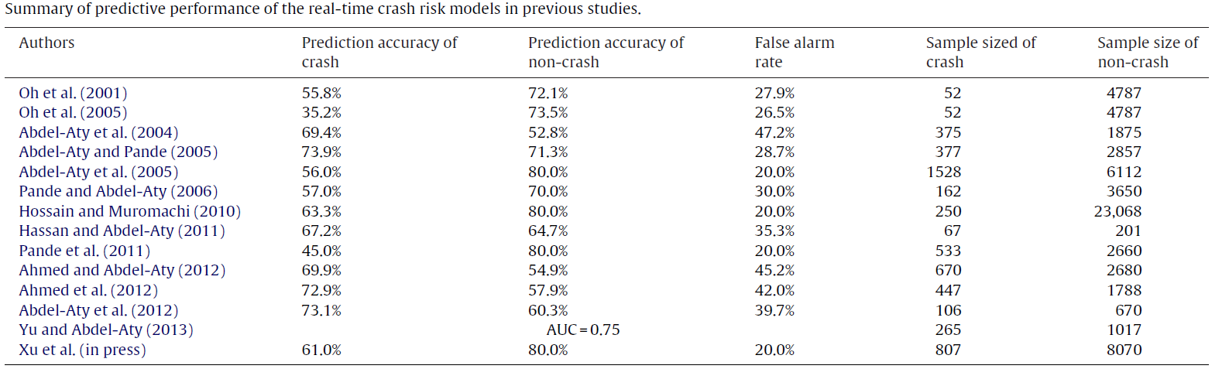

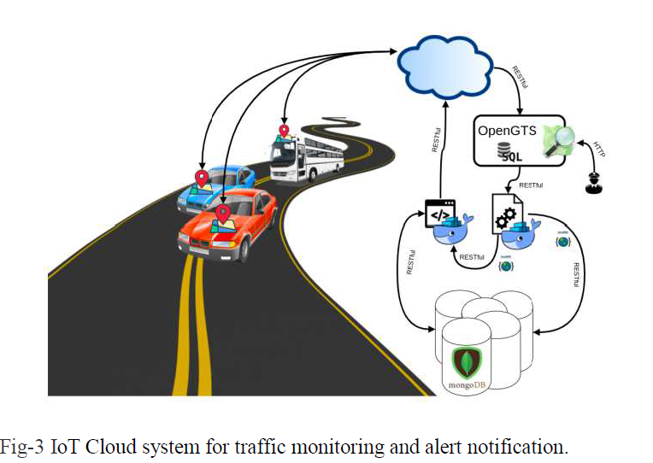

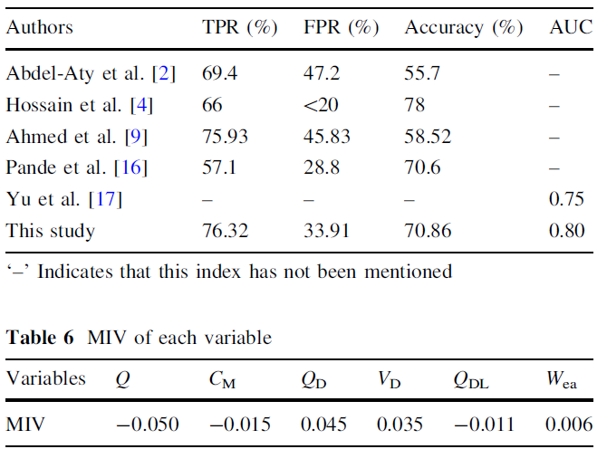

References:
- Abdel-Aty, M. (2003). Analysis of driver injury severity levels at multiple locations using ordered probit models.
- Akin, D., & Akba, B. (2010). A Neural Network (NN) Model to Predict Intersection Crashes Based Upon Driver, Vehicle, and Roadway Surface Characteristics.
- Marchesini, P., & Weijermars, W. (2010). The relationship between road safety and congestion on motorways.
- Xu, C., Tarko, A. P., Wang, W., & Liu, P. (2013). Predicting crash likelihood and severity on freeways with real-time loop detector data.
- Sun, J., & Sun, J. (2014). Real-time crash prediction on urban expressways: identification of key variables and a hybrid support vector machine model.
- Ozbayoglu, M., Kucukayan, G., & Dogdu, E. (2016). A Real-Time Autonomous Highway Accident Detection Model Based on Big Data Processing and Computational Intelligence.
- You, J., Wang, J., & Guo, J. (2017). A novel approach to predicting real-time crash likelihood on freeways.
- Eliseev, M. E., Tomchinskaya, T. N., Galkina, E. D., Dudakov, N. Yu., & Musarsky, R. A. (2018). Interactive System for Road Safety Improvement.
- Abdel-Aty, M. (2018). Real-time crash prediction models: State-of-the-art, design pathways and ubiquitous requirements.
- Safari, M., et al. (2019). A Comprehensive Review on Risk Factors Affecting the Crash Severity.
- Abduljabbar, R., Dia, H., Liyanage, S., & Bagloee, S. A. (2019). Applications of Artificial Intelligence in Transport: An Overview.
- Nascimento, A. M., et al. (2019). The impact of Artificial Intelligence on the safety of Autonomous Vehicles.
- Bhattacharya, S., Jha, H., & Nanda, R. P. (2022). Application of IoT and Artificial Intelligence in Road Safety.
- Olugbade, S., Ojo, S., Imoize, A. L., Isabona, J., & Alaba, M. O. (2022). A Review of Artificial Intelligence and Machine Learning for Incident Detectors in Road Transport Systems.
- Razi, A., Chen, X., Wang, H., Li, H., Russo, B., Chen, Y., & Yu, H. (2022). Deep Learning Serves Traffic Safety Analysis.
- Tselentis, D. I., Papadimitriou, E., & van Gelder, P. (2023). The usefulness of artificial intelligence for safety assessment of different transport modes.

